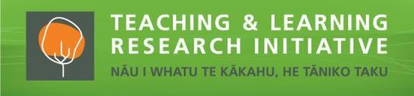
Designing mobile learning with education outside the classroom to enhance marine ecological literacy

Associate Professor Chris Eames (University of Waikato) and Dr Claudio Aguayo (Auckland University of Technology), with Jessica Hanlon, Dr Tim Haggitt, Dr Nick Shears and Dr Thom Cochrane Project dates: 2017-2018

Intro / Project description

This research explores the complementarity of mobile learning and education outside the primary school classroom (EOTC) in the context of marine reserves. It examines the outcomes of a Mixed Reality (MR) intervention to enhance the development of marine ecological literacy. The study team created a mobile learning framework to inform the co-creation of an intervention to influence teaching and learning for students, their teacher and their parents, and promote marine ecological literacy outcomes, including knowledge, attitudes and behaviours for a sustainable future.

Aims
The aim of this study was to explore how purposeful educational design incorporating mobile learning might enable integration of classroom and outside of classroom teaching and learning. An intervention was created and implemented during a unit on marine conservation with one class of Year 5-8 primary students, which included a visit to Goat Island Marine Reserve and the associated Marine Discovery Centre.

Why is this research important?
An ecologically literate citizenry is fundamental to addressing the profound and complex global challenges and social transformations taking place worldwide. Connections to nature and places through education outside the classroom can enhance development of ecological literacy in children but this development can be stifled once back in the classroom if those connections are not reinforced. Mobile tools have the potential to assist learning in diverse, flexible and learner-centred ways, and are increasingly available in schools. These tools could be used to bridge learning between outside the classroom experiences and reinforcement in the classroom leading to long-term outcomes.

Key findings
A purposely designed mobile learning framework informed the development of a Mixed Reality (MR) intervention. This MR intervention created an immersion continuum (between real and digital) for students, from snorkeling in a marine reserve to Augmented Reality games and a Virtual Reality experience.

The MR intervention highly engaged students in learning through a self-directed (heutagogical) approach which enabled learning connections to be made between the marine reserve and associated visitor centre, and the classroom after the visit.

Evidence suggests that knowledge and attitude development occurred for students, and there was adoption of environmentally-friendly behaviour related to plastic pollution which appeared to be connected to learning through the MR intervention.

Implications for practice
- Creating a mobile learning framework is important to provide a solid foundation for designing Mixed Reality into education outside the classroom in any learning context and development of the framework is enhanced through collaboration between diverse partners.
- Mixed Reality can provide an immersion continuum from real to digital experiences. Offering a range of experiences along this continuum can provide effective opportunities for diverse learners. Attention to the local context in designing these experiences is achieved through co-creation of content with partners in ways that are meaningful to the target audience.
- Mixed Reality can also provide a continuum between EOTC activities and classroom activities, reinforcing the learning from outside the classroom into the classroom. A heutagogical learning approach is recommended to assist this.
- Training in heutagogy using mobile tools is important to maximise learning and teaching outcomes for students, teachers and EOTC educators.

Our partners:
This study was a partnership between staff at the Faculty of Education at the University of Waikato, the Centre for Learning and Teaching at the Auckland University of Technology, Ahuroa School, and the University of Auckland’s Institute of Marine Sciences.

Goat Island REEF website is undergoing completion – see https://goatislandreef.nz/. This will house information on the project, provide access to QR code and AR markers, and host outputs.

Contact details:
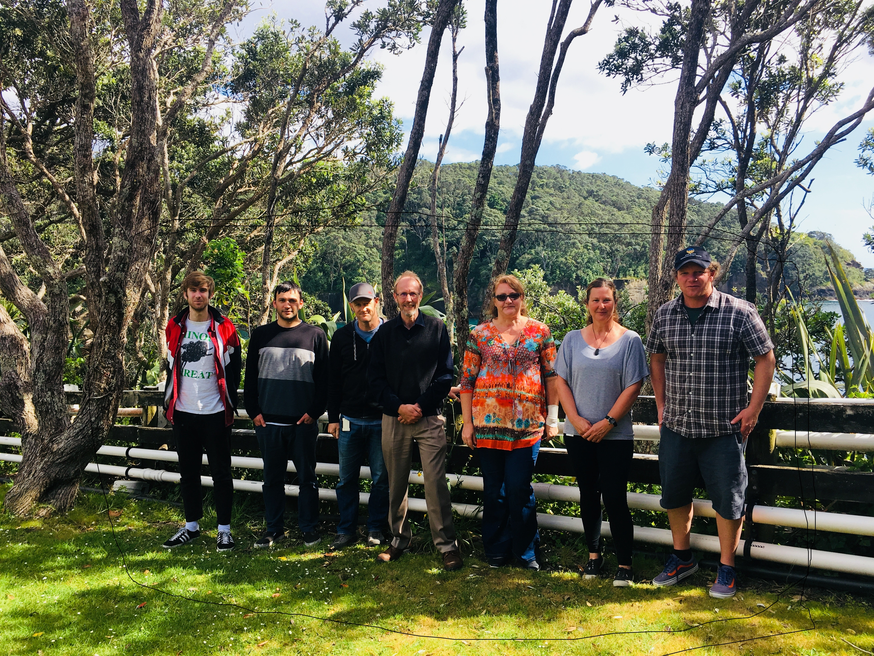

Chris Eames, c.eames@waikato.ac.nz,
07 838 4357

Claudio Aguayo, claudio.aguayo@aut.ac.nz,
09 921 9999

